**WHAT'S THE GREAT PUMPKIN DERBY?** Handcrafted Pumpkin Racers racing side-by-side in unpredictable and dramatic style! Families and friends race for fun and the coveted Championship Trophy. Recognition for Best of Show, Best Team Spirit, and Best Crash.

**NEED A PUMPKIN RACER?**  Pumpkin Derby Racer Kits will be **available for purchase** at the DERBY while supplies last! Pumpkin Racer Kits are fun and easy to assemble and contain everything you need to build a Pumpkin Racer, including a medium-sized pumpkin. Free expert assistance, decorations, and accessories are available at the event for those purchasing official kits. Kits are $20.00.

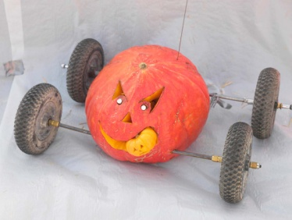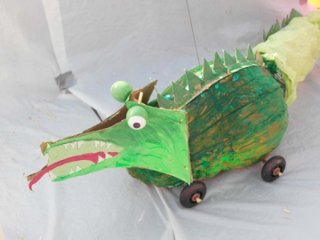 One pumpkin racer per person is allowed for the perspective races. Get a cheering squad together to cheer your pumpkin racer on to victory. Ribbons will be given for the most spirited racer crew. No items are allowed inside the pumpkins that would be CHEATING!

**OFFICIAL PUMPKIN RACE RULES RULES**

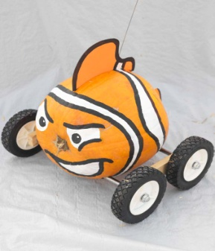

THE OFFICIAL RULES:

All Pumpkin Racers must design and race their Pumpkin Racers according to these few important rules to ensure that the Pumpkin Race is fun and fair for everyone.

* **RULE #1** Craft your Pumpkin Racer using a single pumpkin.
* **RULE #2**  Insert two independent axels through your pumpkin and attach wheels to the axels. Spice up your racer with style.
* **RULE #3**  You may not attach your pumpkin onto a pre-fabricated chassis of any kind (skateboard, stroller, Tonka truck, etc., etc...) A.K.A. The "Anti-Stealth" Rule.
* **RULE #4** NO EXPLOSIVES or PYROTECHNICS.
* **RULE #5** No pushing or "helping" your Pumpkin Racer on the starting line. Our Race Officials have seen it all - the last minute shove, the hidden thumb flick, the early release, the remote control chassis, etc. etc. See Rule #6.
* **RULE #6** NO CHEATING. Feel great about being honest and fair. Don't be tempted to be a Cheater Pumpkin. Use the honor system and obey the spirit of these rules. Our Race Officials have a keen eye and the CHEATER BEATER will be ready to bring a Cheater Pumpkin down by being **SQUASHED!!!**

***WITH YOUR RIGHT HAND OVER YOUR HEART, REPEAT THE SOLEMN PUMPKIN RACER PLEDGE:***

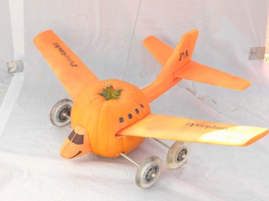"I pledge to always do my very best and play by the rules because Cheater Pumpkins never prosper."   
**This is the Pumpkin Racer Pledge**

**Congratulations, Pumpkin Racer.**

**http://www.pumpkinrace.com/images/H1-flagLeft.gif Racing Tips http://www.pumpkinrace.com/images/H1-flagRight.gif**

**TIPS FROM THE PUMPKIN RACE PROS**

* Be sure to read the [**Official Rules**](http://www.pumpkinrace.com/official_rules.html) to understand how to build a "legal" Pumpkin Racer.
* A bigger or heavier Pumpkin Racer is not a faster Pumpkin Racer. Rarely does the biggest win.
* The best way to build a fast Racer is to make sure the axles are *parallel* so it will roll straight down the track. This will keep your pumpkin from hitting the wall.
* Make sure all of your wheels spin freely! Duh!?! ***And have FUN!!!!***

**There will be different categories to race in.**

Race #1 – Ages 3 – 6

Race #2 – Ages 7-12

Race #3 – Ages 13 – infinity

Corporate Competition

Final Race will be with all winners of each division races. The winner of this race will be the champion pumpkin racer. Ribbons will be given to each racer. Each racer winner will receive a ribbon and the winner of each category will receive a trophy and the grand champion winner will get a large trophy with cash.

**REGISTRATION FORM: Mail registration slip with $5.00 for each entry to: SWFBC at the Bay 24388 US HWY 288 Santa Rosa Beach, FL 32459**

**NAME:**

**______________________________**

**ADDRESS:**

**________________________________________**

**________________________________________**

**________________________________________**

**AGE: __________________________________**

**PHONE: _______________________________**

**There is a $5.00 registration fee for all pumpkin racers entered to race. If you purchased a racer kit for $20.00 the registration fee was included. All games are free to play, there will be food and drinks sold.**

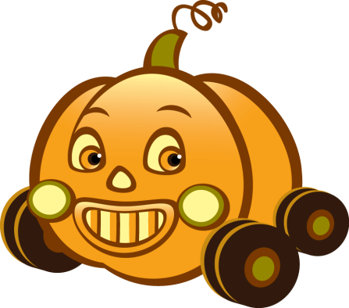

**WHERE: *SOUTH WALTON BAY CHURCH 24388 US HWY 331 SOUTH SANTA ROSA BEACH, FL 32459***

**WHEN: OCTOBER 25, 2014**

**TIME: 1:00 PM – 4:00 PM**

**For more information contact:**

**Dr. Walt Campbell -850-685-0684**

**or** [**the_celt@panhandle.rr.com**](mailto:the_celt@panhandle.rr.com)

**THANK YOU TO OUR SPONSORS:**

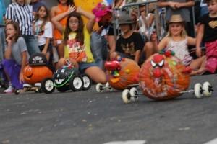



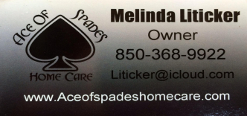





***Saturday – 10/25/14 Presented by: Church at the Bay***

**READY, SET, GO! Gather your family and friends and get your little pumpkins to the 1st Annual Pumpkin Derby.  Enjoy the fun and activities at South Walton where creativity runs wild and cheaters never prosper.  Come enjoy fun activities for all ages, make your own Pumpkin Racer and feel the thrill of competing in the fun-spirited Pumpkin** **Derby.**

***We don’t race horses we race pumpkins.***